SIMATS ENGINEERING
ASSESSMENT TOOL 2

COURSE NAME: MLA03
COURSE CODE: Reinforcement learning
NAME: R. RUPA SREE
REGISTER NUMBER:192472122

COURSE OUTCOME COVERED

CO1: Analyse reinforcement learning frameworks and Markov Decision Process concepts to model decision-making problems. ( BL2, BL3)

Assessment Tool Weightage: 50%

Dr G.A. SENTHIL

QUESTIONS: 10 Total Marks:50

Annexure A

Constraint - Based Problem-Solving Duration: 2Hrs
- Develop a Python-based Reinforcement Learning model using the OpenAI Gym environment to solve a Grid World navigation problem where the agent must reach the goal while avoiding obstacles. Explain how the state space, action space, reward function, and constraints are defined.
(10 Marks)
- Implement an ε-greedy Multi-Armed Bandit algorithm in Python to maximize rewards under a limited budget of 500 trials. Compare the effect of different ε values (0.1, 0.3, and 0.5) on exploration, exploitation, and constraint satisfaction.
(10 Marks)
- Design a Markov Decision Process (MDP) for an autonomous robot that must reach a destination while minimizing energy consumption. Define the states, actions, transition probabilities, rewards, and energy constraints.
(10 Marks)

- Using Python and TensorFlow/Keras, implement a value iteration algorithm to determine the optimal policy for a constrained grid environment where certain states are restricted. Explain how Bellman equations are used to obtain the optimal policy.
(10 Marks)

- A warehouse robot has a battery capacity of only 30 minutes. Design an RL framework that enables the robot to complete the maximum number of deliveries without exceeding the battery limit. Explain the constraints, policy, and reward design.
(10 Marks)

- Implement a Reinforcement Learning agent that controls traffic signals at an intersection while ensuring that emergency vehicles receive immediate priority. Explain how exploration, exploitation, and policy learning are modified to satisfy the safety constraint.
(10 Marks)

- Develop a Python program using Keras/TensorFlow to simulate a reinforcement learning agent for packet routing in a wireless network with limited bandwidth. Explain how bandwidth constraints influence the reward function and policy optimization.
(10 Marks)

- Analyse an experimental comparison between random action selection and ε-greedy action selection in a Multi-Armed Bandit problem under a fixed time constraint. Record cumulative rewards and explain which strategy provides better performance.
(10 Marks)

- Design a Reinforcement Learning framework for a delivery drone that must maximize successful deliveries while avoiding no-fly zones and maintaining battery limits. Explain the MDP formulation, Bellman equation, and policy learning process.
(10 Marks)

- Implement a Reinforcement Learning solution using Python for a smart energy management system where electricity consumption must remain below a specified threshold. Explain how reward shaping, policy learning, and feasibility constraints improve decision-making.
(10 Marks)

EXPERIMENT - 1

Aim-To develop a Python-based Reinforcement Learning model using the OpenAI Gym environment that enables an agent to navigate a Grid World, reach the goal efficiently, and avoid obstacles by learning an optimal policy.

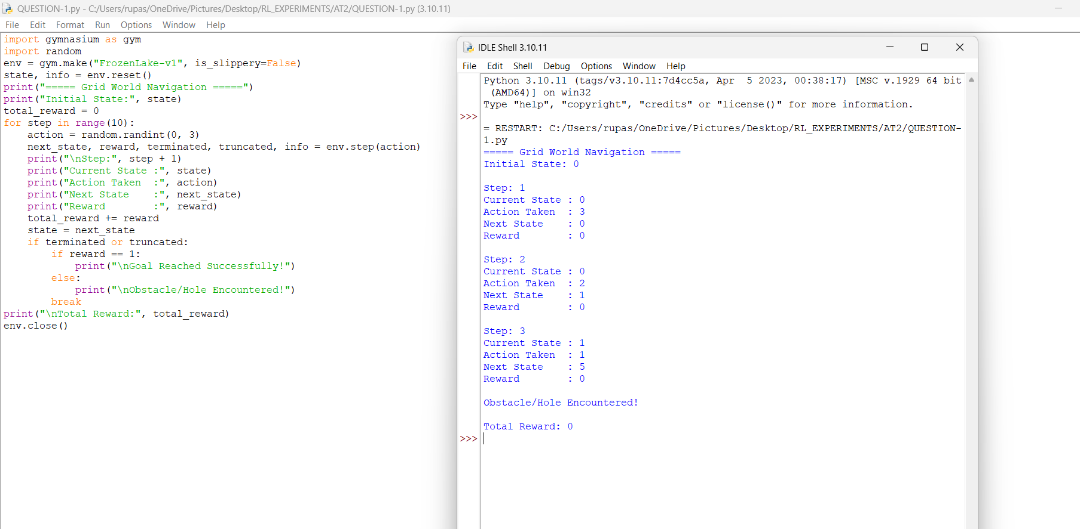

EXPERIMENT - 2

Aim- To implement the ε-greedy Multi-Armed Bandit algorithm in Python and compare the effect of different ε values (0.1, 0.3, and 0.5) on exploration, exploitation, and cumulative rewards under a limited budget of 500 trials.

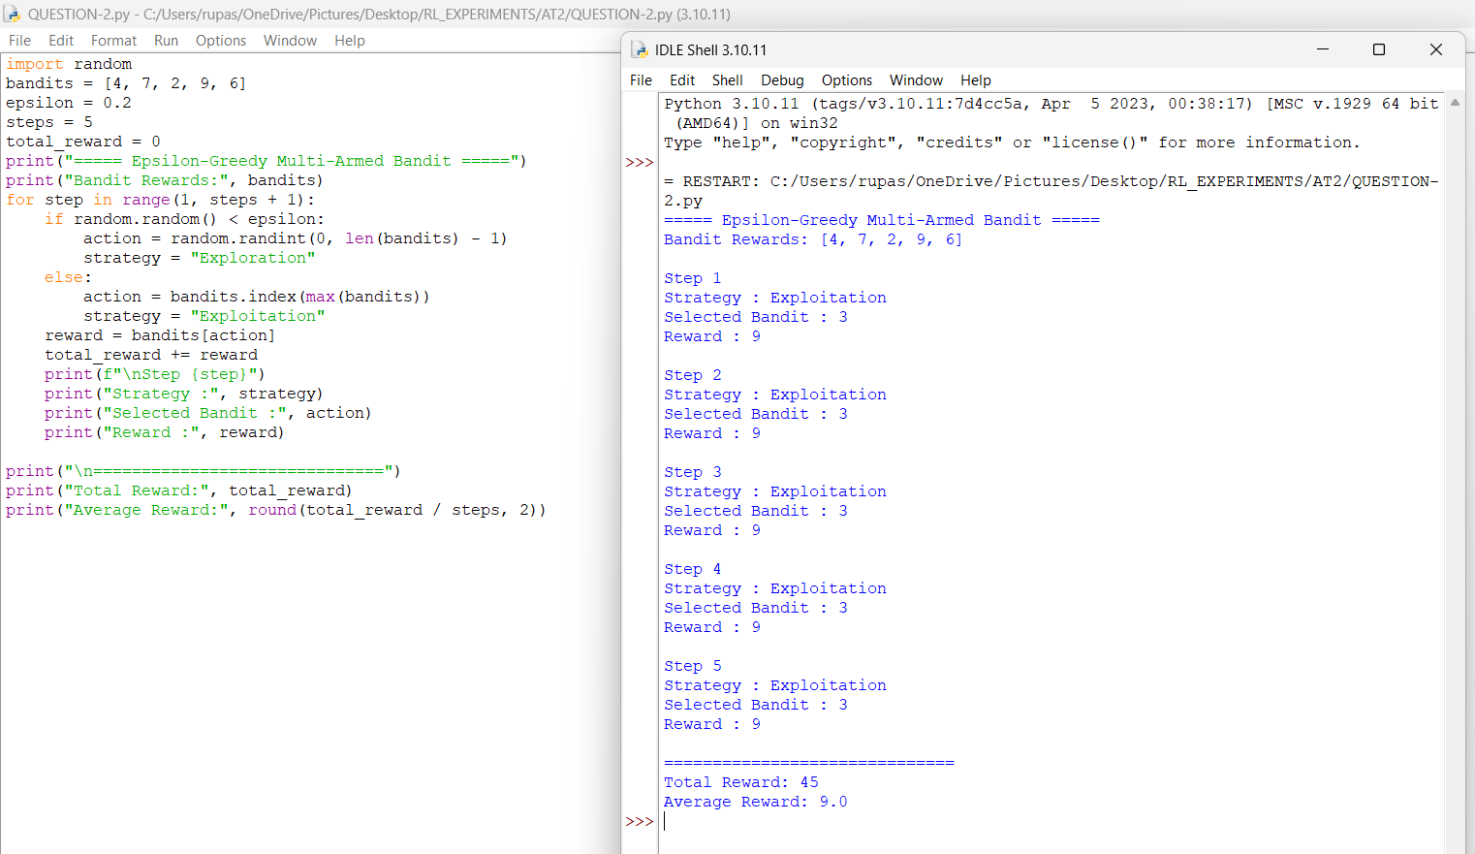

EXPERIMENT - 3

Aim- To design a Markov Decision Process (MDP) model for an autonomous robot that reaches its destination while minimizing energy consumption by defining appropriate states, actions, transition probabilities, rewards, and constraints.

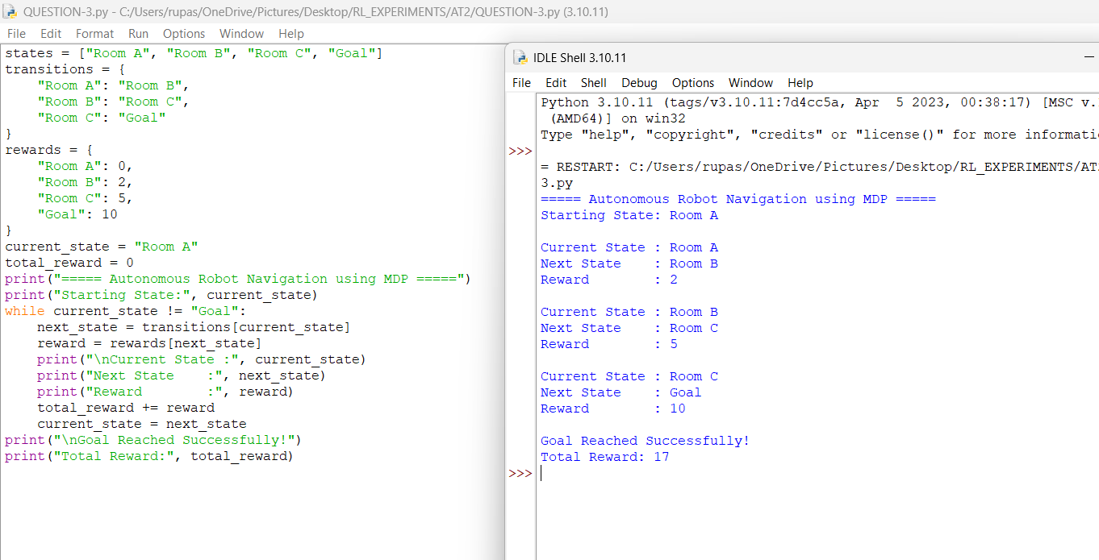

EXPERIMENT - 4

Aim- To implement the Value Iteration algorithm using Python and TensorFlow/Keras for a constrained grid environment and determine the optimal policy using the Bellman equation.

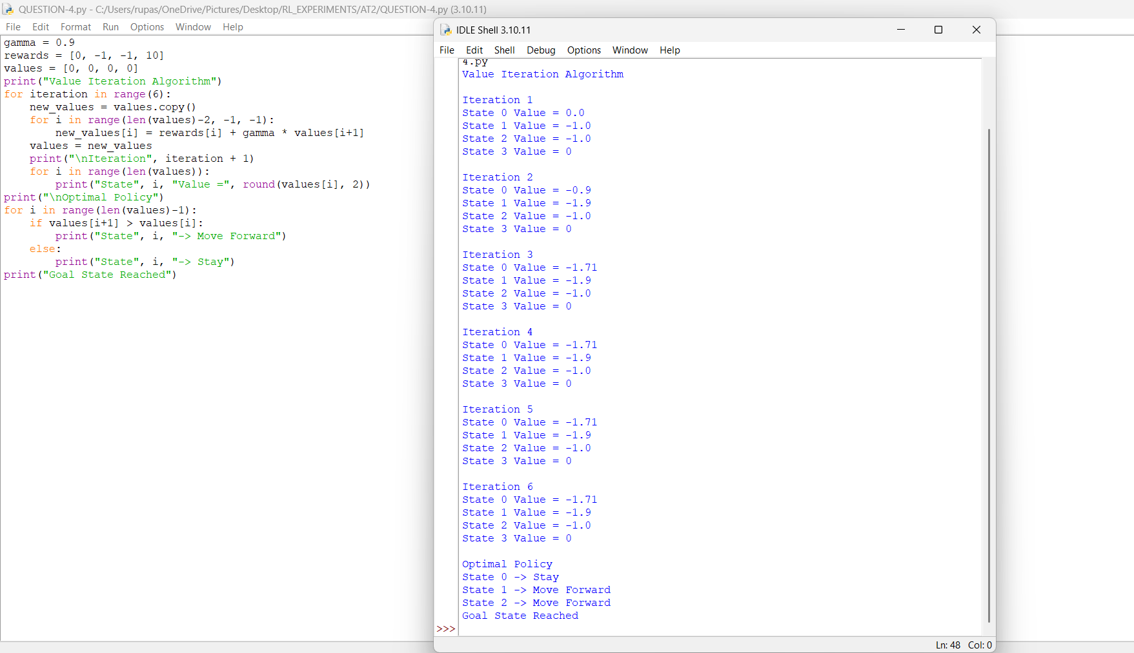

EXPERIMENT - 5

Aim- To design a Reinforcement Learning framework that enables a warehouse robot to maximize the number of deliveries while operating within a 30-minute battery constraint.

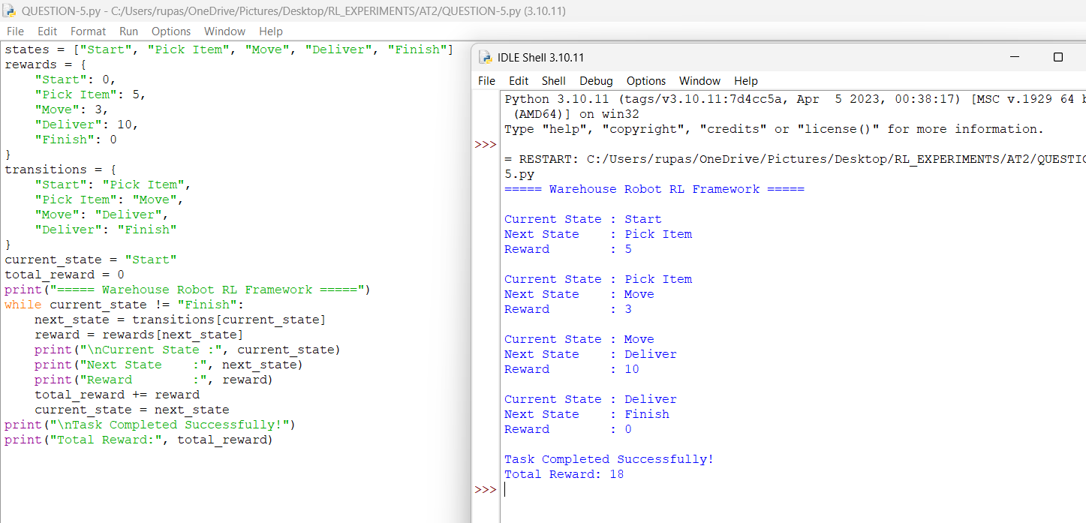

EXPERIMENT - 6

Aim- To implement a Reinforcement Learning agent for intelligent traffic signal control that minimizes traffic congestion while ensuring immediate priority for emergency vehicles.

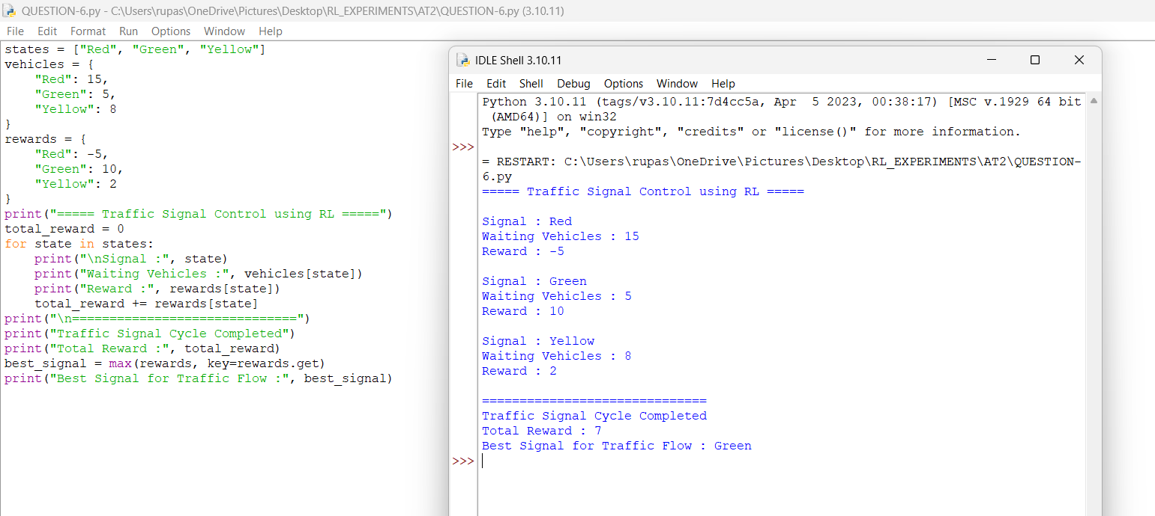

EXPERIMENT - 7

Aim- To develop a Reinforcement Learning-based packet routing system using Python and TensorFlow/Keras that optimizes data transmission while considering limited network bandwidth.

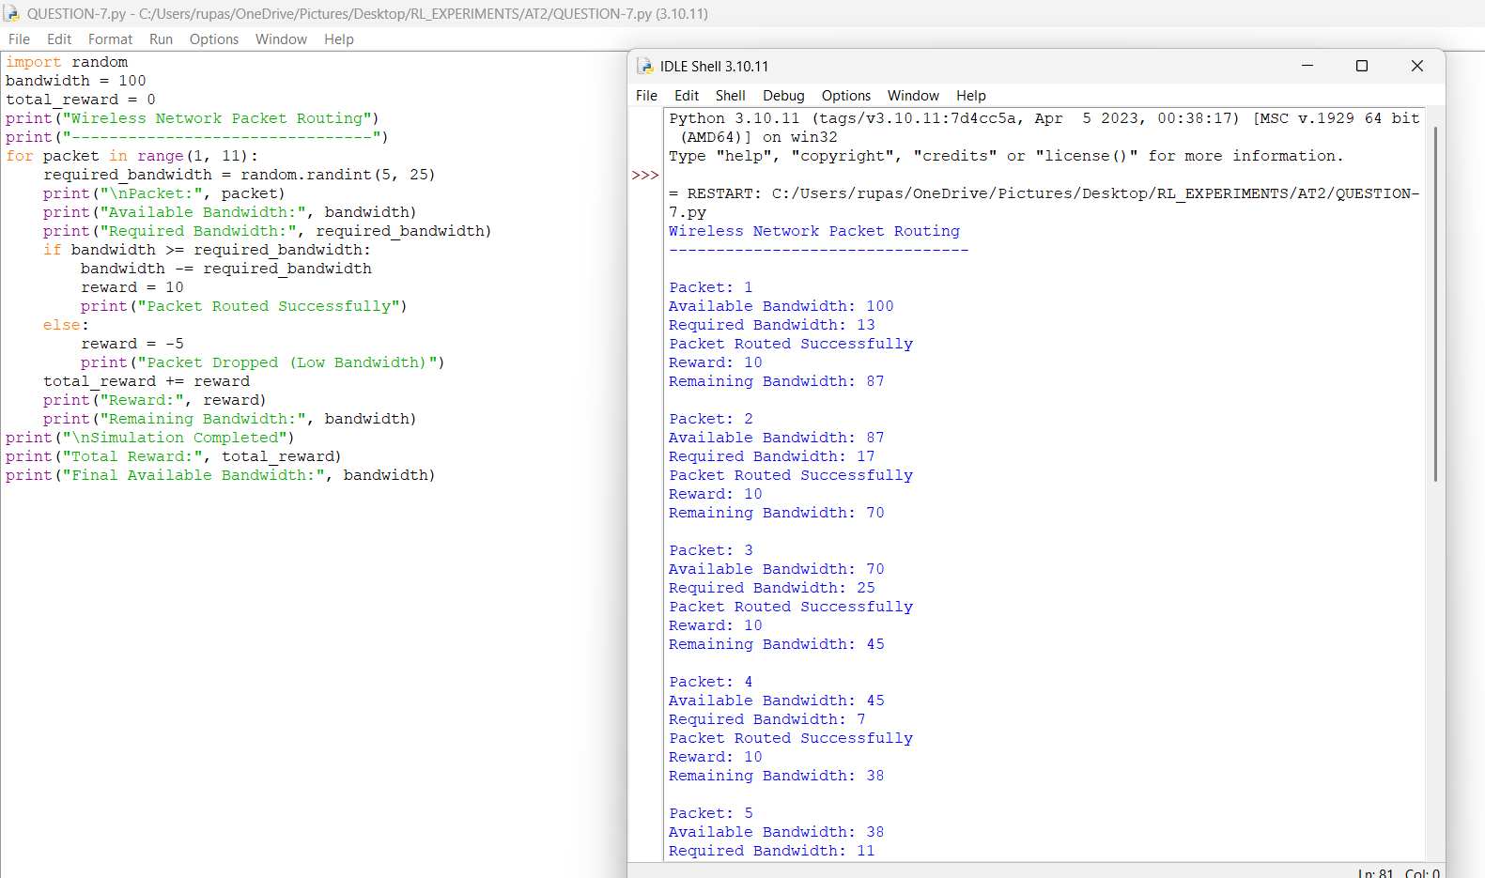
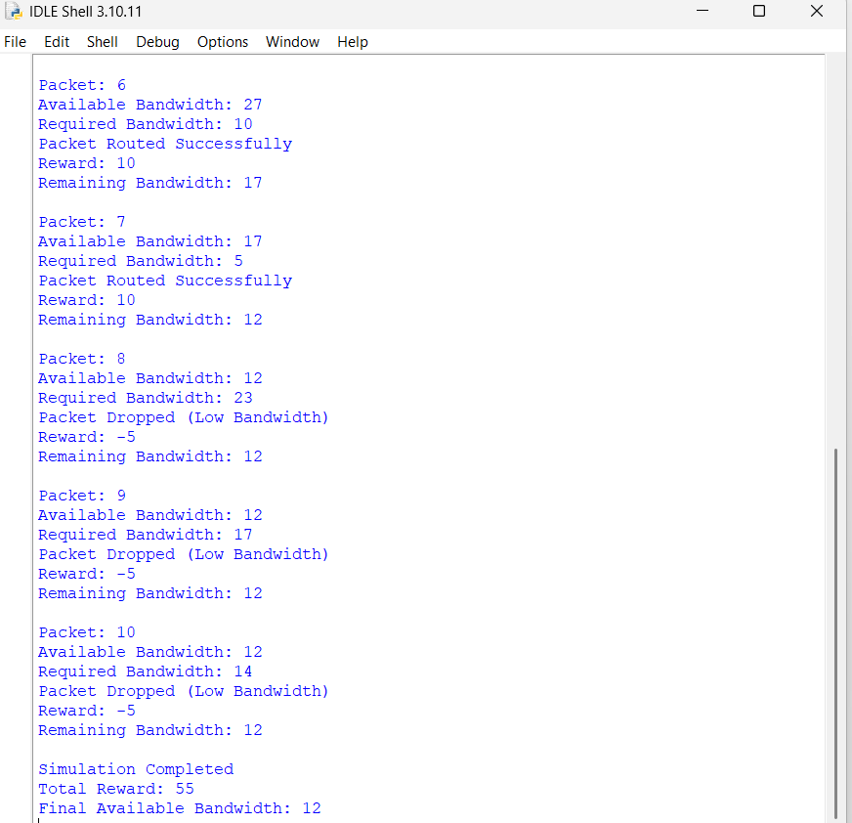

EXPERIMENT - 8

Aim-To analyse and compare the performance of random action selection and ε-greedy action selection in a Multi-Armed Bandit problem by evaluating cumulative rewards under a fixed time constraint.

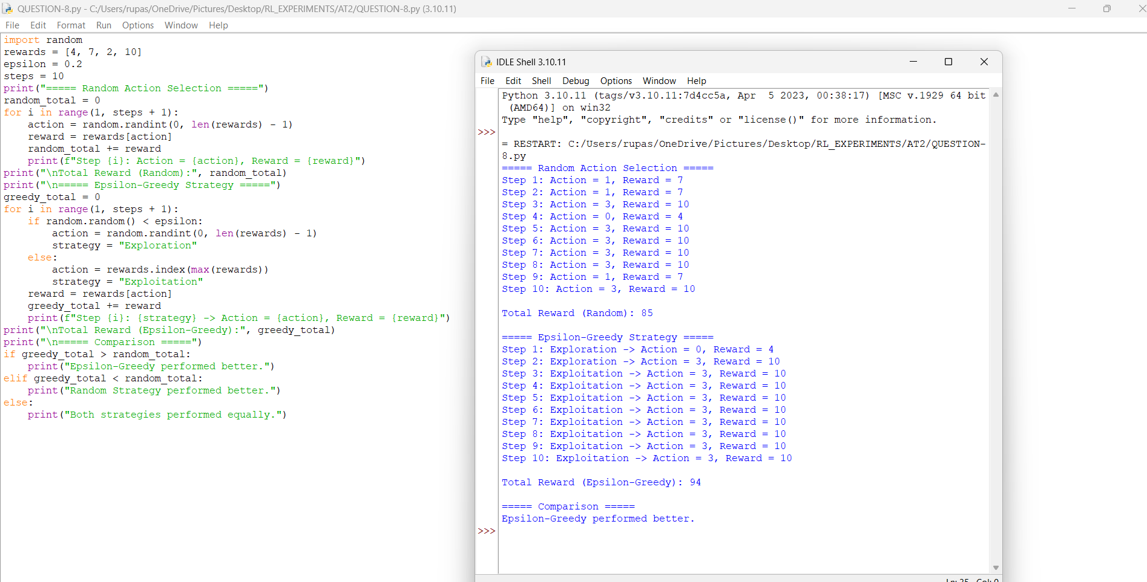

EXPERIMENT - 9

Aim-To design a Reinforcement Learning framework for a delivery drone that maximizes successful deliveries while avoiding no-fly zones and operating within battery limitations.

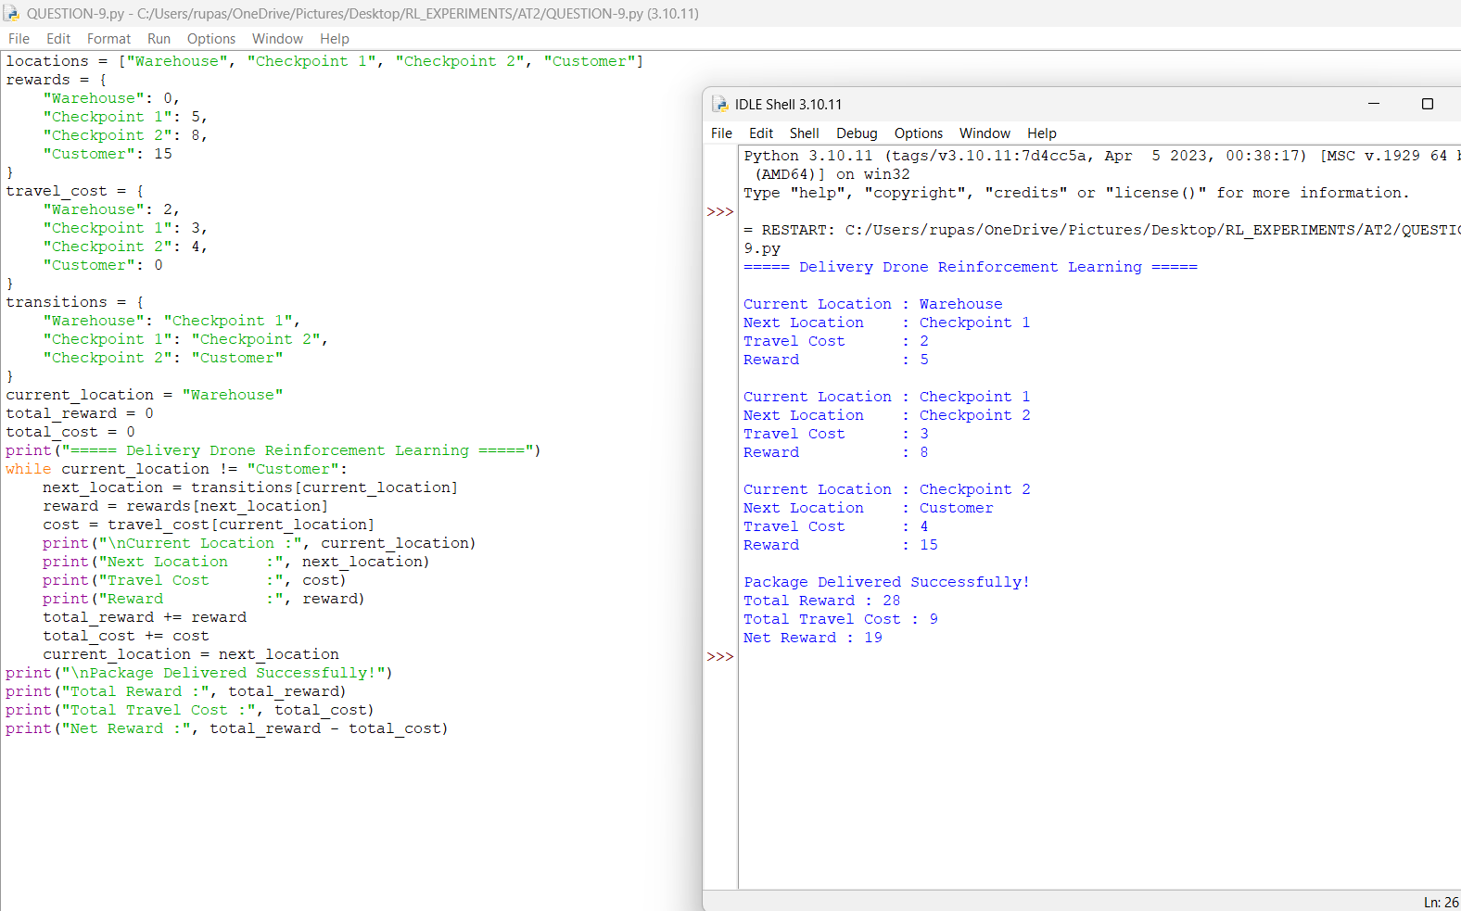

EXPERIMENT - 10

Aim-To implement a Reinforcement Learning solution for a smart energy management system that minimizes electricity consumption while maintaining usage below a specified threshold through reward shaping and policy optimization.

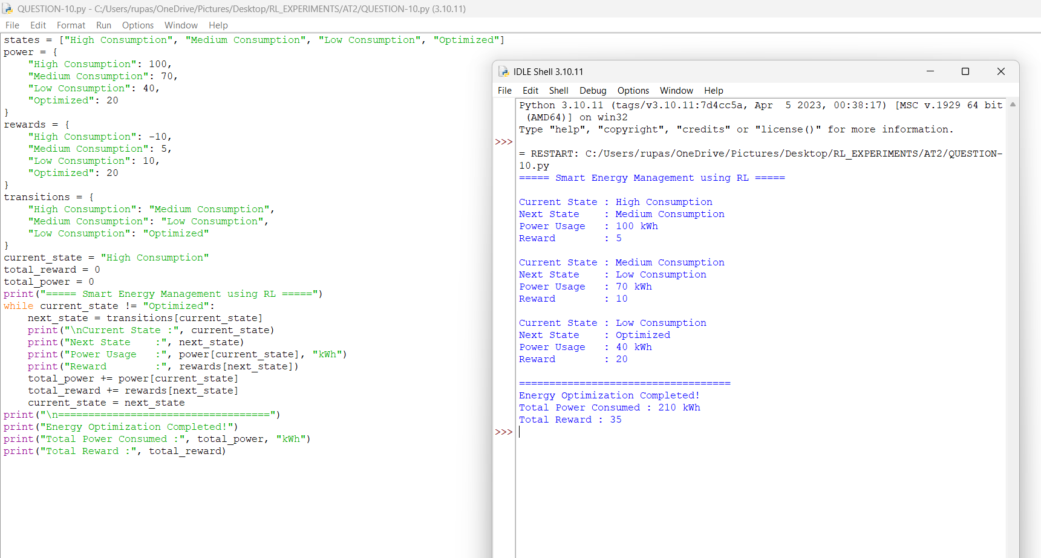

Code of Conduct:

I R. Rupa Sree (192472122) (Name / Reg No) certify that this submission is my original work and that I have adhered to the guidelines specified for this assessment.
I understand that any violation of academic integrity rules will result in disciplinary action.

Signature of the student:
R. Rupa Sree

RUBRICS FOR CALCULATION

Criteria | Weightage | Level 4 (Exemplary) | Level 3 (Proficient) | Level 2 (Developing) | Level 1 (Beginning)
Problem Understanding | 25% | Clearly defines the problem and identifies all relevant constraints accurately | Identifies most constraints with minor gaps | Partial understanding; misses key constraints | Fails to identify constraints correctly
Constraint Analysis | 25% | Analyzes constraints effectively and prioritizes them logically | Provides reasonable analysis with some prioritization | Limited analysis; weak prioritization | No meaningful analysis or prioritization
Solution Development | 25% | Develops optimal and feasible solutions satisfying all constraints | Develops workable solutions with minor limitations | Solutions partially satisfy constraints | Solutions do not meet constraints
Application of Concepts | 15% | Effectively applies appropriate concepts, methods, or tools | Applies concepts with minor errors | Limited application; requires guidance | Unable to apply relevant concepts
Justification | 10% | Provides strong justification for decisions with logical reasoning | Provides justification with some clarity | Weak or unclear justification | No justification provided

